Assignment I

- Answer all questions.

- Who is responsible for coordinating and guiding employees in an organization?

Someone who works with and through other people by coordinating their work activities in order to accomplish organizational goals.
- Why is management important in an organization?

The process of coordinating work activities so that they are completed efficiently and effectively with and through other people. The process represents the ongoing functions or primary activities engaged in by managers. These functions are typically labeled planning, organizing, leading, and controlling
- How do managers contribute to the success of an organization?

Managers engage in many short, varied activities and frequently switch between tasks (Henry Mintzberg, John Kotter). They spend most of their time interacting with people—employees, supervisors, and external stakeholders. Around two-thirds of their time is communication (meetings, calls, conversations). Managers rarely work alone and often handle interruptions and unexpected issues.
Their role includes:
Gathering information
Building relationships
Solving problems
Coordinating work
Communication is the key tool for guiding actions and ensuring smooth operations. Managers achieve top performance by being active, adaptable, and highly connected through effective communication.

- What are the roles that managers play in organizations?
The Roles Managers Play (Mintzberg’s Roles)
Managers perform three main types of roles in organizations: interpersonal, informational, and decisional.
1. Interpersonal Roles
These involve interacting with people and building relationships. Managers act as:
Figurehead: perform ceremonial and symbolic duties.
Leader: motivate, guide, and manage employees.
Liaison: build networks and maintain contacts inside and outside the organization.
2. Informational Roles
Managers handle and share information. They act as:
Monitor: gather and analyze information from the environment.
Disseminator: share important information with employees.
Spokesperson: communicate information to external stakeholders and the public.

3. Decisional Roles
Managers make important organizational decisions. They act as:
Entrepreneur: initiate change and innovation.
Disturbance Handler: respond to crises and unexpected problems.
Resource Allocator: decide how to distribute limited resources.
Negotiator: handle negotiations with employees, suppliers, and other parties.
Overall, managers use these roles together to lead, communicate, and make decisions that help organizations achieve their goals.

- What are Mintzberg’s managerial roles, and why are they important?
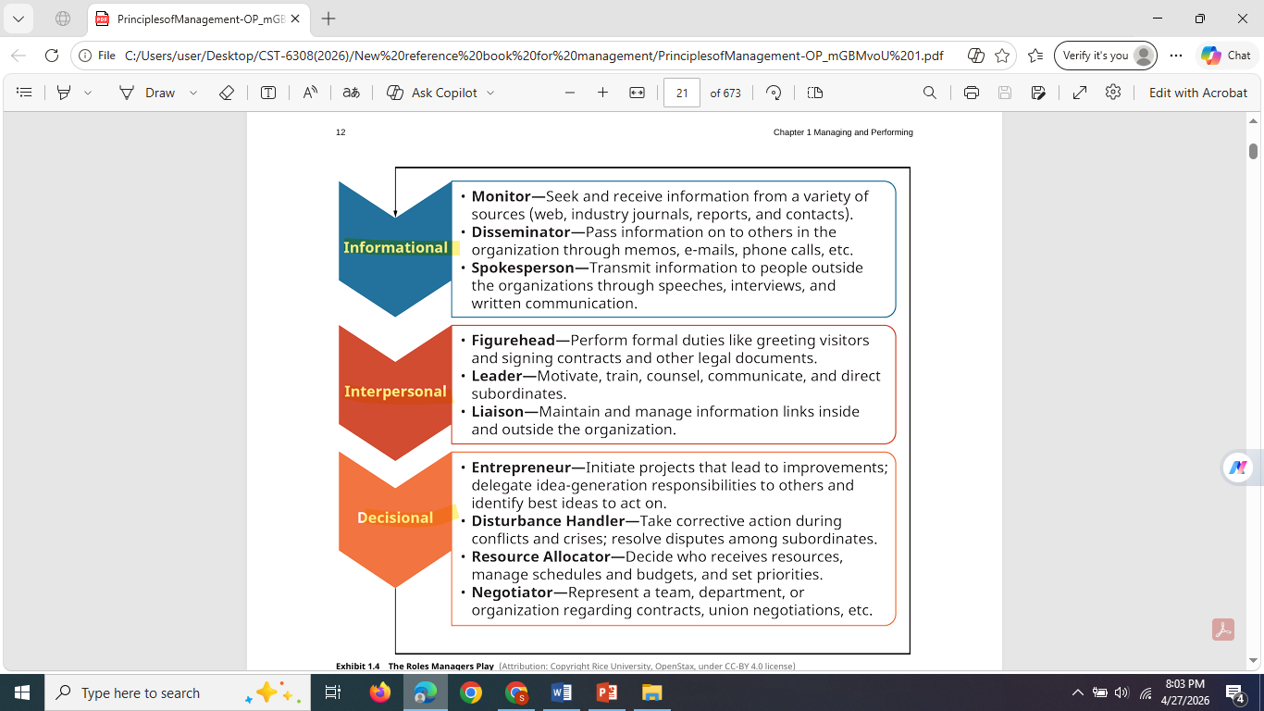

- Which characteristics are commonly found in successful managers?

Work in a Fast-Paced Environment
Operate in demanding and dynamic conditions
Handle constant changes and high expectations
Manage Fragmented Time
Perform many short tasks throughout the day
Deal with frequent interruptions
Rely heavily on verbal communication
Handle Conflicting Demands
Balance needs of employees, customers, and shareholders
Prioritize tasks and make fair, balanced decisions
Cope with Work Overload
Manage larger teams in flatter organizations
Take on increased responsibilities due to fewer management layers
Demonstrate High Efficiency
Use limited time wisely
Stay productive under pressure
Adapt quickly to changing demands.

- What Varies in a Manager’s Job?
Why do managerial jobs differ from one manager to another?
The manager’s job is always changing, but two roles are becoming especially more important:
- The emphasis in a manager’s job changes based on the environment and organizational needs, with certain roles becoming more important over time.
- Entrepreneurial Role (Increasing Importance)
    - Identify threats (competition, technological changes)
    - Recognize opportunities (new markets, innovation, improvements)
- Leadership Role (Growing Significance)
    - Be proactive and adaptable to stay competitive
    - Act as mentors and strategic leaders, not just supervisors
    - Attract, train, motivate, and retain talented employees
Modern managers must be both innovative (entrepreneurial) and people-focused (leadership-oriented) to help organizations achieve and sustain high performance.

- How do managerial responsibilities contribute to achieving organizational goals?
Managers are responsible for planning, organizing, directing, and controlling organizational activities. Their work includes nine main types of responsibilities:
Long-range planning: Involved in strategic planning and development.
Controlling: Evaluate and take corrective action on human, financial, and material resources.
Environmental scanning: Monitor changes and business indicators.
Supervision: oversee subordinates’ work.
Coordinating: Coordinate work within and outside the team.
Customer relations and marketing: Direct contact with customers and potential customers.
Community relations: Maintain relationships with external groups (agencies, civic groups, suppliers).
Internal consulting: Use technical expertise to solve internal problems, acting as inside consultants for organizational change and development.
Monitoring products and services: Plan, schedule, and monitor production and delivery..

- Read the following Case Study: New Management Challenges for the New Age. Answer the following questions.

Today’s news is littered with scandals, new allegations of sexual assault, and tragedy. Since 2017 and the #metoo Movement, stemming from the Harvey Weinstein scandal, more and more public figures have been put into the spotlight to defend themselves against allegations from women around the globe. Not only publically, but privately in companies around the world, there have been firings, and investigations into misconduct from co-workers, managers, and CEOs. It is a relevant topic that is getting long overdue publicity and encouraging more men and women to come forward to discuss openly rather than hide the events and injustices of the past. Other events showcase the tumultuous and on-edge society we are living in,such as the Charlottesville, VA attack, that left 1 dead and 19 injured when a person drove a car through a crowd of protestors during a white nationalist gathering.With events on a daily business, it is important for companies to take a stand against racial hatred, harassment of any kind, and have firm policies when such events occur. Take Netflix for example, who in July of 2018 fired chief communications officer for saying the “N-word” in full form. This event occurred during an internal meeting, not directing the slur at anyone specific, but claimed it was being made as an emphatic point about offensive words in comedy programming. The “Netflix way”, the culture that is built around radical candor and transparency was put to the test during this occurrence.The offender, Jonathan Friedland attempted to apologize for his misdeed, hoping it would fade away and his apology would be accepted. However, it didn’t work that way, instead the anger was palpable between coworkers, and eventually led to the firing of Friedland after a few months of inaction. Netflixers are given a high level of freedom and responsibility within their “Netflix way” culture. Blunt feedback is encouraged, trust and discretion is the ultimate gate keeper, as employees have access to sensitive information, and are ultimately trusted for how they expense items and take vacation time.
crowd of protestors during a white nationalist gathering. With events on a daily business, it is important for companies to take a stand against racial hatred, harassment of any kind, and have firm policies when such events occur. Take Netflix for example, who in July of 2018 fired chief communications officer for saying the “N-word” in full form. This event occurred during an internal meeting, not directing the slur at anyone specific, but claimed it was being made as an emphatic point about offensive words in comedy programming. The “Netflix way”, the culture that is built around radical candor and transparency was put to the test during this occurrence. The offender, Jonathan Friedland attempted to apologize for his misdeed, hoping it would fade away and his apology would be accepted. However, it didn’t work that way, instead the anger was palpable between coworkers, and eventually led to the firing of Friedland after a few months of inaction. Netflixers are given a high level of freedom and responsibility within their “Netflix way” culture. Blunt feedback is encouraged, trust and discretion is the ultimate gate keeper, as employees have access to sensitive information, and are ultimately trusted for how they expense items and take vacation time. Between the insanely fast-paced streaming services industry, it is hard to keep this culture at a premium, but it is imperative for the success of the company overall. “As you scale a company to become bigger and bigger how do you scale that kind of culture?” said Colin Estep, a former senior engineer who left voluntarily in 2016. “I don’t know that we ever had a good answer.” In order to keep up, sometimes the company is seen as harsh in their tactics to keep the best of the best. “I think we’re transparent to a fault in our culture and that can come across as cutthroat,” said Walta Nemariam, an employee in talent acquisition at Netflix, in the video.Netflix has stayed true to their cultural values despite the pressures and sometimes negative connotations associated with this “cutthroat” environment. Their ability to remain agile, while displaying no tolerances for societal injustices makes them at the forefront of new age companies. It is a difficult pace to stay in line with, but it seems that they are keeping in stride and remaining true to who they are, for now.
Questions:
1. How have the current cultural environment of our country shaped the way that companies are looking at their own corporate cultural standards?
2. What are the potential downfalls and positive influences of the “Netflix way”?
3. How does Netflix’s internal culture negatively or positively affect their ability to stay competitive and deliver cutting edge content?

